Onshore Wind Targets

[Onshore wind energy atlas for the United States accounting for land use restrictions and wind speed thresholds - ScienceDirect](https://www.sciencedirect.com/science/article/pii/S2666955221000460)

From Appendix:

NJ: Potential nameplate capacity (GW) that can be realized if SG 2.6-114 turbines are installed in all available land area: **42**, compared to 2050 target nameplate capacity (GW) **16**



Potential Energy Output (TWh)



Potential Nameplate Capacity (GWh)

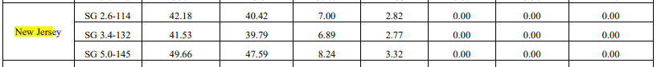

Number of Turbines that Fit within Available Area for Wind Energy Development

